Guañez, Adrian Mark M.
Polytechnic University of the Philippines SMB

HandsMen Threads: Elevating the Art of Sophistication in Men's Fashion

Project Overview
HandsMen Threads is a Salesforce CRM–based project developed for a premium men’s fashion brand. The system is designed to centralize business data and automate key operational processes, including customer management, order processing, inventory tracking, and marketing engagement. By leveraging Salesforce declarative tools and Apex-based automation, the CRM improves operational efficiency, ensures data accuracy, and enhances customer experience through real-time notifications, role-based access control, and proactive inventory monitoring.
Key features of the system include automated order confirmations, low-stock alerts, customer loyalty management, and role-specific access for sales, marketing, and inventory teams.

Objectives
The primary objective of this project is to develop a Salesforce-based system that centralizes business data and automates essential operational processes for a men’s fashion enterprise. The system is designed to improve data accuracy, enhance workflow efficiency, and support informed decision-making.
Specifically, the project aims to:
- Design a custom data model aligned with business requirements to store and manage critical information.
- Automate order confirmations and inventory monitoring by sending email notifications to customers after successful order confirmation.
- Implement proactive stock alerts that notify the inventory team when stock levels fall below five units to prevent stock shortages.
- Develop a customer loyalty program that updates loyalty status based on purchase history, encouraging repeat purchases.
- Ensure secure system access through the implementation of user roles and profiles.
These objectives directly support business value by reducing manual effort, minimizing stock shortages, and improving customer engagement.

DETAILED EXECUTION OF PROJECT PHASES
Phase 1: Requirement Analysis & Planning
Understanding Business Requirements
HandsMen Threads operates as a premium men’s fashion brand requiring efficient handling of customer data, orders, inventory, and marketing campaigns. Manual tracking of orders and stock posed risks such as data inconsistency, delayed customer communication, and inventory shortages. The CRM system addresses these challenges through automation and centralized data management.

Defining Project Scope and Objectives
The project scope includes customer management, order lifecycle automation, inventory tracking, marketing campaign management, and role-based security. The system excludes external e-commerce payment integrations and focuses on internal CRM efficiency.

Data Model and Security Model Design
Custom objects such as HandsMen Customer, HandsMen Order, HandsMen Product, Inventory, and Marketing Campaign were designed with appropriate relationships, validation rules, and formula fields. A role-based security model ensures users access only relevant data.

Stakeholder Mapping
- Sales Team: Manages customers and orders
- Inventory Team: Monitors and updates stock levels
- Marketing Team: Handles campaigns and customer engagement
- System Administrator: Manages configuration and security

Execution Roadmap
The project was executed in phases: planning and analysis, backend development, UI customization, testing and security implementation, and final deployment and documentation.

Phase 2: Salesforce Development - Backend & Configurations
Setup environment & DevOps workflow:
- Creating Developer Account
- Creating a developer org in salesforce.
- Account Activation
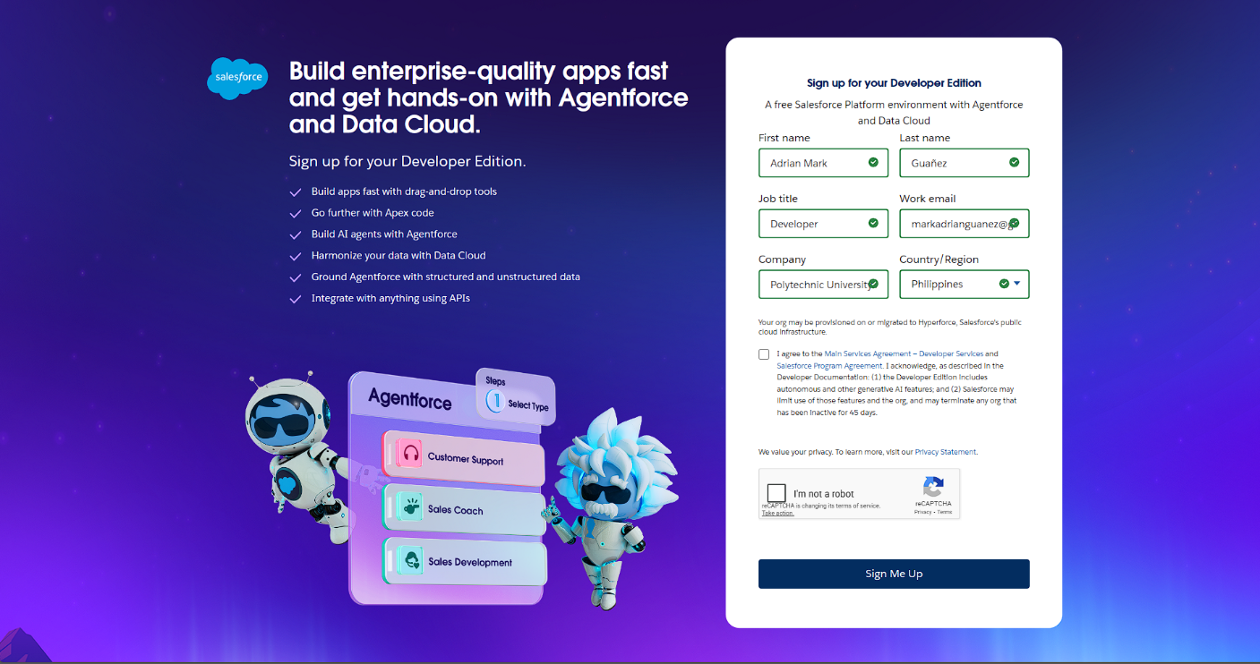

App, Object and field creation:
- The following are the Custom objects which we created
  - HandsMen Customer
  - HandsMen Order
  - HandsMen Product
  - Inventory
  - Marketing Campaign
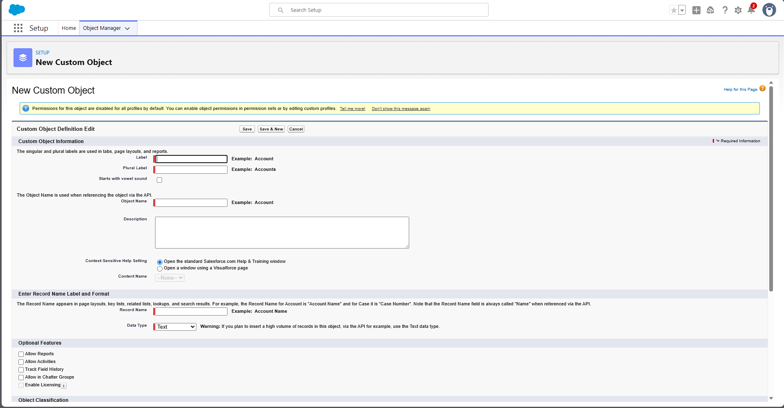

- Data Management Tabs Creation for each object
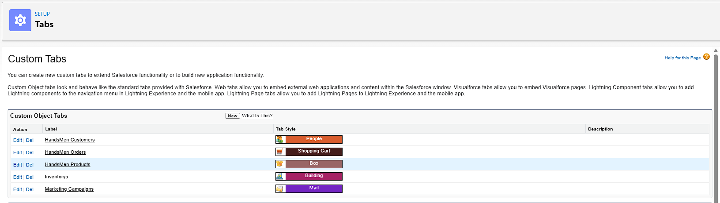
- Creation in Salesforce Platform
- The following are the fields that we created in objects:
    - HandsMen Customer:
    - First Name
    - Last Name
    - Email (Email),
    - Phone (Phone),
    - Loyalty Status (Picklist: Bronze, Gold, Silver)
    - Total Purchases (Number)

    - HandsMen Product:
    - Name (Record Name),
    - SKU ( Text ),
    - Price (Currency),
    - Stock_Quantity__c (Number)

    - HandsMen Order:
    - Order_Number (Record Name),
    - Status (Picklist: Pending, Confirmed, Rejection),
    - Quantity__c (Number),
    - Total_Amount__c(Number)

    - Inventory:
    - Auto Number (Record Name),
    - Warehouse (Text),
    - Stock_Quantity__c (Number)

    - Marketing Campaigns:
    - Campaign_Name (Record Name),
    - Start_Date (Date),
    - End_Date (Date)

- Formula Fields:
- FullName (HandsMen Customer)
Formula : FirstName & " " & LastName
- Stock Status (Inventory)
Formula : IF(Stock_Quantity__c > 10, "Available", "Low Stock")

- Lookup Relations:
  - Marketing Campaign and HandsMen Customer
  - HandsMen Product and HandsMen Order
  - HandsMen Order and HandsMen Customer

- Master-Detail Relationship:
- Inventory and HandsMen Product

Validation Rules:
Validation rules were implemented to maintain data integrity, such as preventing negative order totals, invalid stock quantities, and incorrect email formats.
Sno. | Object | Field | Validation Rule
1. | HandsMen Order | Total Amount | Total_Amount__c <= 0
2. | Inventory | Stock Quantity | Stock_Quantity__c < = 0
3. | HandsMen Customer | Email | NOT CONTAINS(Email, "@gmail.com")
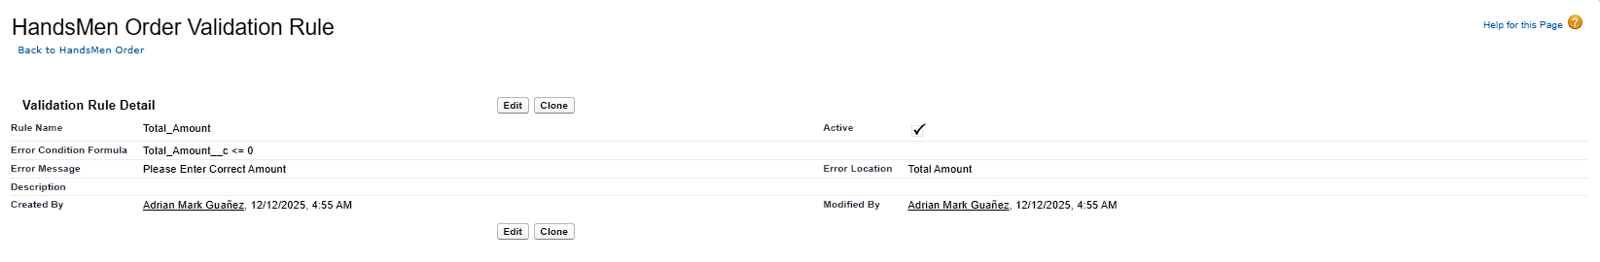
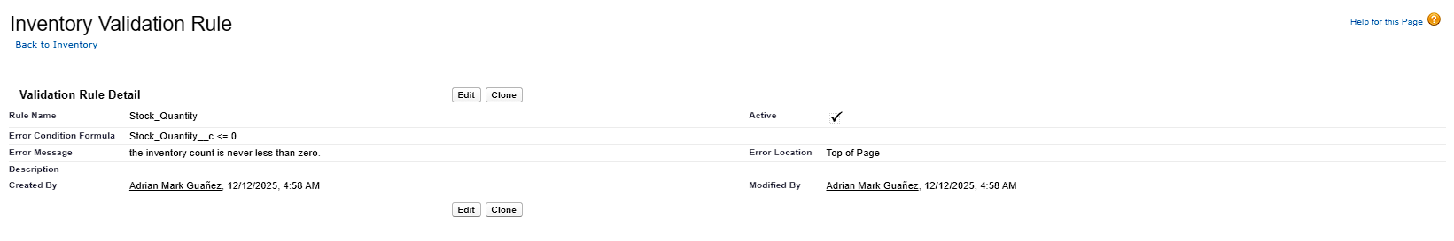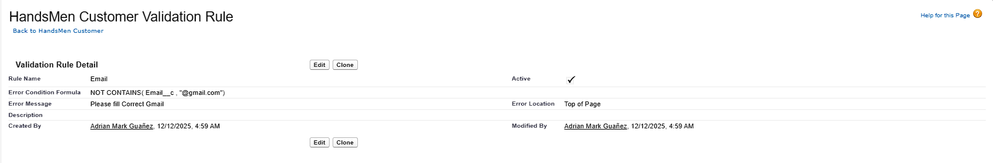

Flows:
- Order Confirmation Flow: Sends an automated email when an order status is updated to Confirmed.
- Low Stock Alert Flow: Notifies the inventory team when stock levels fall below five units.
- Loyalty Program Flow: A scheduled flow that updates customer loyalty status based on purchase history.
Sno. | Flow Name | Type | Trigger Condition
1. | Order Confirmation | Record-Triggered | Trigger: When a record is updated  Condition: Order__c.Status__c = "Confirmed"
2. | Low Stock Alert | Record-Triggered | Trigger: When a record is created or updated  Condition: Stock_Quantity__c < 5
3. | Loyalty program | Schedule-Triggered Flow | Trigger: Runs Daily  Condition : to update Loyality_Status_c
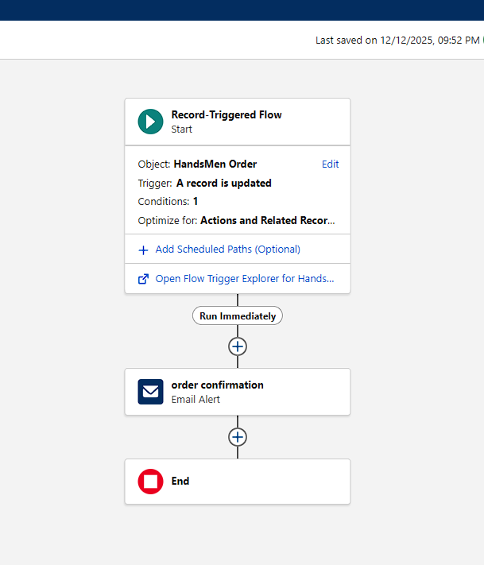
Fig: Order Confirmation Flow

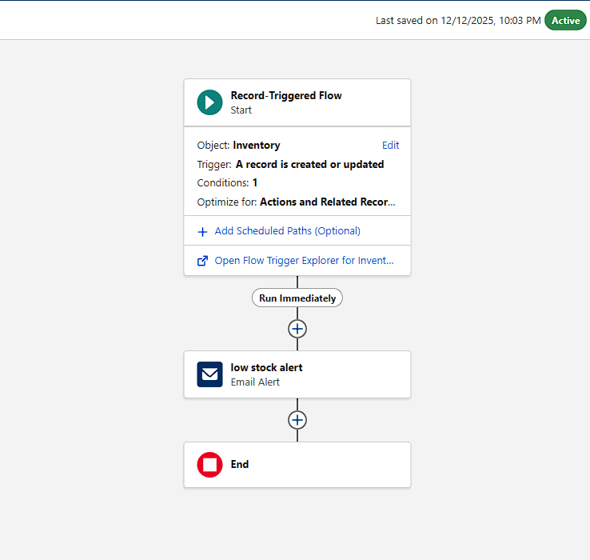
Fig: Low Stock Alert Flow

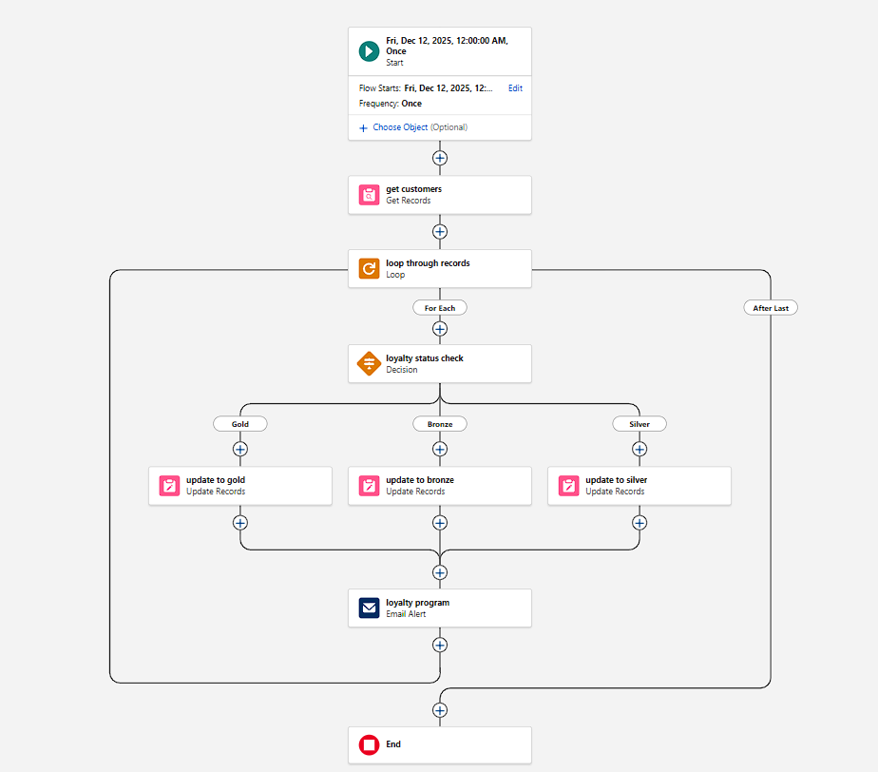
Fig: Loyalty Program Flow

Phase 3: UI/UX Development & Customization
Data Security Profiles Creation:
- “Platform 1”

Data Security Roles Creation:
- Sales
- Marketing
- Inventory

Data Security User Creation:
Users for the three security roles
- Sales : Niklaus Mikaelson
- Marketing : Daniel Mikaelson
- Inventory : Kol Mikaelson

Fig: Users with new Roles

Email Template:
Creating the following email templates:
Template Name | Type | Trigger
Order Confirmation | HTML | Sent when Order is placed
Low Stock Alert | Text | Sent when Inventory__c.Stock_Quantity__c < 5
Loyalty Program Email | HTML | Sent when customer qualifies for loyalty rewards

Order Confirmation Email Template:-
Dear {!HandsMen_Order__c.HandsMen_Customer__c},
Your order #{!HandsMen_Order__c.Name} has been confirmed!
Thank you for shopping with us.
Best Regards,
Sales Team
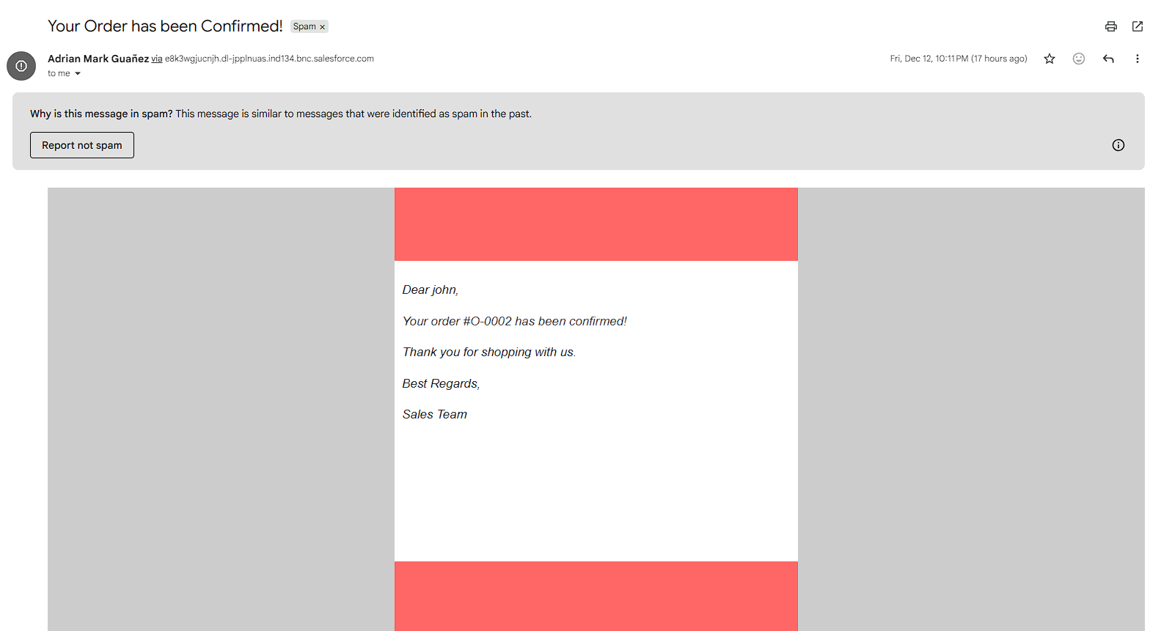
Fig: Order Confirmation Email Template

Low Stock Alert Email Template:-
Dear Inventory Manager,
This is to inform you that the stock for the following product is running low:
Product Name: {!Inventory__c.HandsMen_Product__c}
Current Stock Quantity: {!Inventory__c.Stock_Quantity__c}
Please take the necessary steps to restock this item immediately.
Best Regards,
Inventory Monitoring System
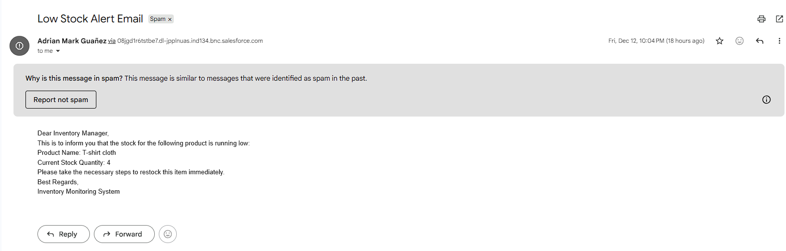
Fig: Low Stock Alert Email Template

Loyality Points Email Template:-
Congratulations! You are now a {!HandsMen_Customer__c.Loyalty_Status__c} member and you are eligible for our Loyalty Rewards Program.
Enjoy exclusive discounts, early access to offers, and special member benefits.
Thank you for your continued Support.
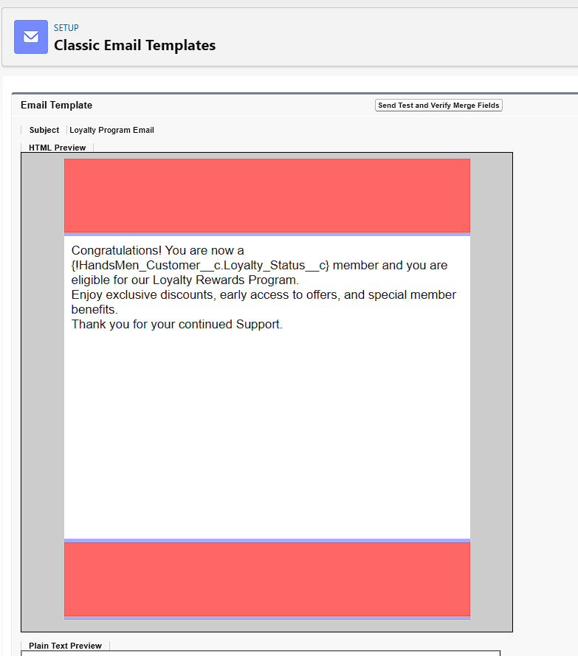
Fig: Loyalty Email Template

Phase 4: Data Migration, Testing & Security
Data Security - Permission Set:
S no. | Role | Access Level
1. | Sales Manager | Full Access to Customers, Orders
2. | Inventory Manager | Read & Edit on Inventory, Products
3. | Marketing Team | Read on Customers, Edit on Marketing Campaigns

Automation using Apex
Apex Triggers
Trigger Name | Object | Purpose
Update Order Total | Order__c | Auto-update Total_Amount__c on order save
Stock Deduction | Inventory__c | Reduce stock when an order is placed
Loyalty Status Update | Customer__c | Upgrade loyalty status based on purchases

Update Order Total :-
trigger OrderTotalTrigger on HandsMen_Order__c (before insert, before update) {
Set<Id> productIds = new Set<Id>();

for (HandsMen_Order__c order : Trigger.new) {
if (order.HandsMen_Product__c != null) {
productIds.add(order.HandsMen_Product__c);
}
}

Map<Id, HandsMen_Product__c> productMap = new Map<Id, HandsMen_Product__c>(
[SELECT Id, Price__c FROM HandsMen_Product__c WHERE Id IN :productIds]
);

for (HandsMen_Order__c order : Trigger.new) {
if (order.HandsMen_Product__c != null && productMap.containsKey(order.HandsMen_Product__c)) {
HandsMen_Product__c product = productMap.get(order.HandsMen_Product__c);
if (order.Quantity__c != null) {
order.Total_Amount__c = order.Quantity__c * product.Price__c;
}
}
}
}

Stock Deduction Trigger:-
trigger StockDeductionTrigger on HandsMen_Order__c (after insert, after update) {
Set<Id> productIds = new Set<Id>();

for (HandsMen_Order__c order : Trigger.new) {
if (order.Status__c == 'Confirmed' && order.HandsMen_Product__c != null) {
productIds.add(order.HandsMen_Product__c);
}
}
if (productIds.isEmpty()) return;
// Query related inventories based on product
Map<Id, Inventory__c> inventoryMap = new Map<Id, Inventory__c>(
[SELECT Id, Stock_Quantity__c, HandsMen_Product__c
FROM Inventory__c
WHERE HandsMen_Product__c IN :productIds]
);

List<Inventory__c> inventoriesToUpdate = new List<Inventory__c>();

for (HandsMen_Order__c order : Trigger.new) {
if (order.Status__c == 'Confirmed' && order.HandsMen_Product__c != null) {
for (Inventory__c inv : inventoryMap.values()) {
if (inv.HandsMen_Product__c == order.HandsMen_Product__c) {
inv.Stock_Quantity__c -= order.Quantity__c;
inventoriesToUpdate.add(inv);
break;
}
}
}
}

if (!inventoriesToUpdate.isEmpty()) {
update inventoriesToUpdate;
}
}

Batch Jobs:
Description
Batch Job | Purpose | Schedule
Loyalty Points Calculation | Updates customer points weekly | Every Sunday 12 AM
Inventory Sync | Syncs stock levels with external warehouse system | Daily at 2 AM

Source Code:
global class InventoryBatchJob implements Database.Batchable<SObject>, Schedulable {
global Database.QueryLocator start(Database.BatchableContext BC) {
return Database.getQueryLocator(
'SELECT Id, Stock_Quantity__c FROM Product__c WHERE Stock_Quantity__c < 10'
);
}
global void execute(Database.BatchableContext BC, List<SObject> records) {
List<HandsMen_Product__c> productsToUpdate = new List<HandsMen_Product__c>();
// Cast SObject list to Product__c list
for (SObject record : records) {
HandsMen_Product__c product = (HandsMen_Product__c) record;
product.Stock_Quantity__c += 50; // Restock logic
productsToUpdate.add(product);
}
if (!productsToUpdate.isEmpty()) {
try {
update productsToUpdate;
} catch (DmlException e) {
System.debug('Error updating inventory: ' + e.getMessage());
}
}
}
global void finish(Database.BatchableContext BC) {
System.debug('Inventory Sync Completed');
}
// Scheduler Method
global void execute(SchedulableContext SC) {
InventoryBatchJob batchJob = new InventoryBatchJob();
Database.executeBatch(batchJob, 200);
}
}

Execute anonymous window code:-
System.schedule('Daily Inventory Sync', '0 0 0 * * ?', new InventoryBatchJob());

Phase 5:Deployment, Documentation & Maintenance
Deployment Strategy
The system can be deployed using change sets to migrate components between environments.

Maintenance and Monitoring
Ongoing maintenance includes monitoring automation performance, reviewing debug logs, and updating configurations as business requirements evolve.

Troubleshooting Approach
Common issues are addressed through Salesforce debug logs, validation rule analysis, and flow error monitoring.

Screenshots:
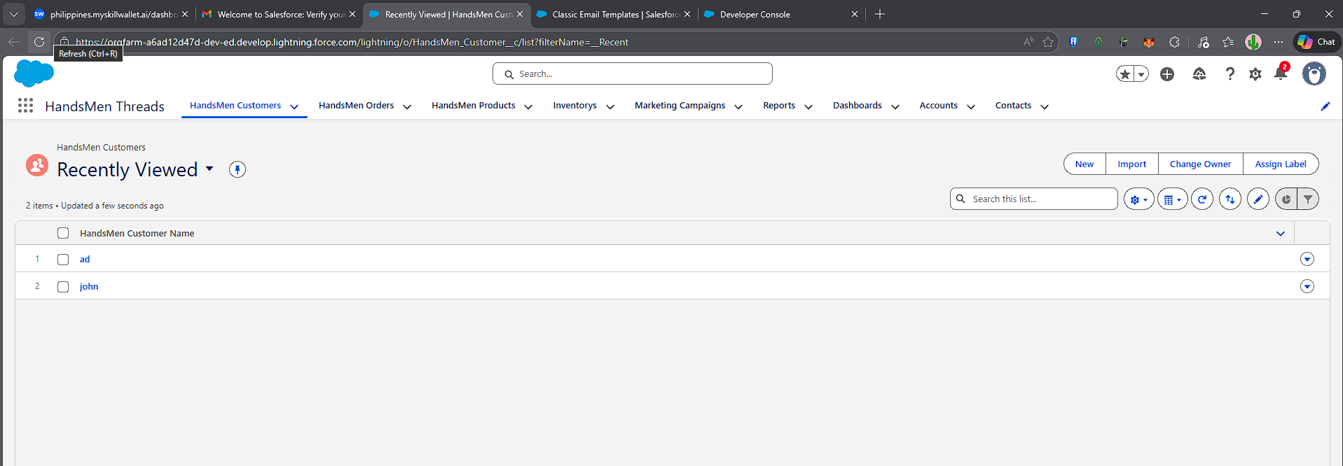
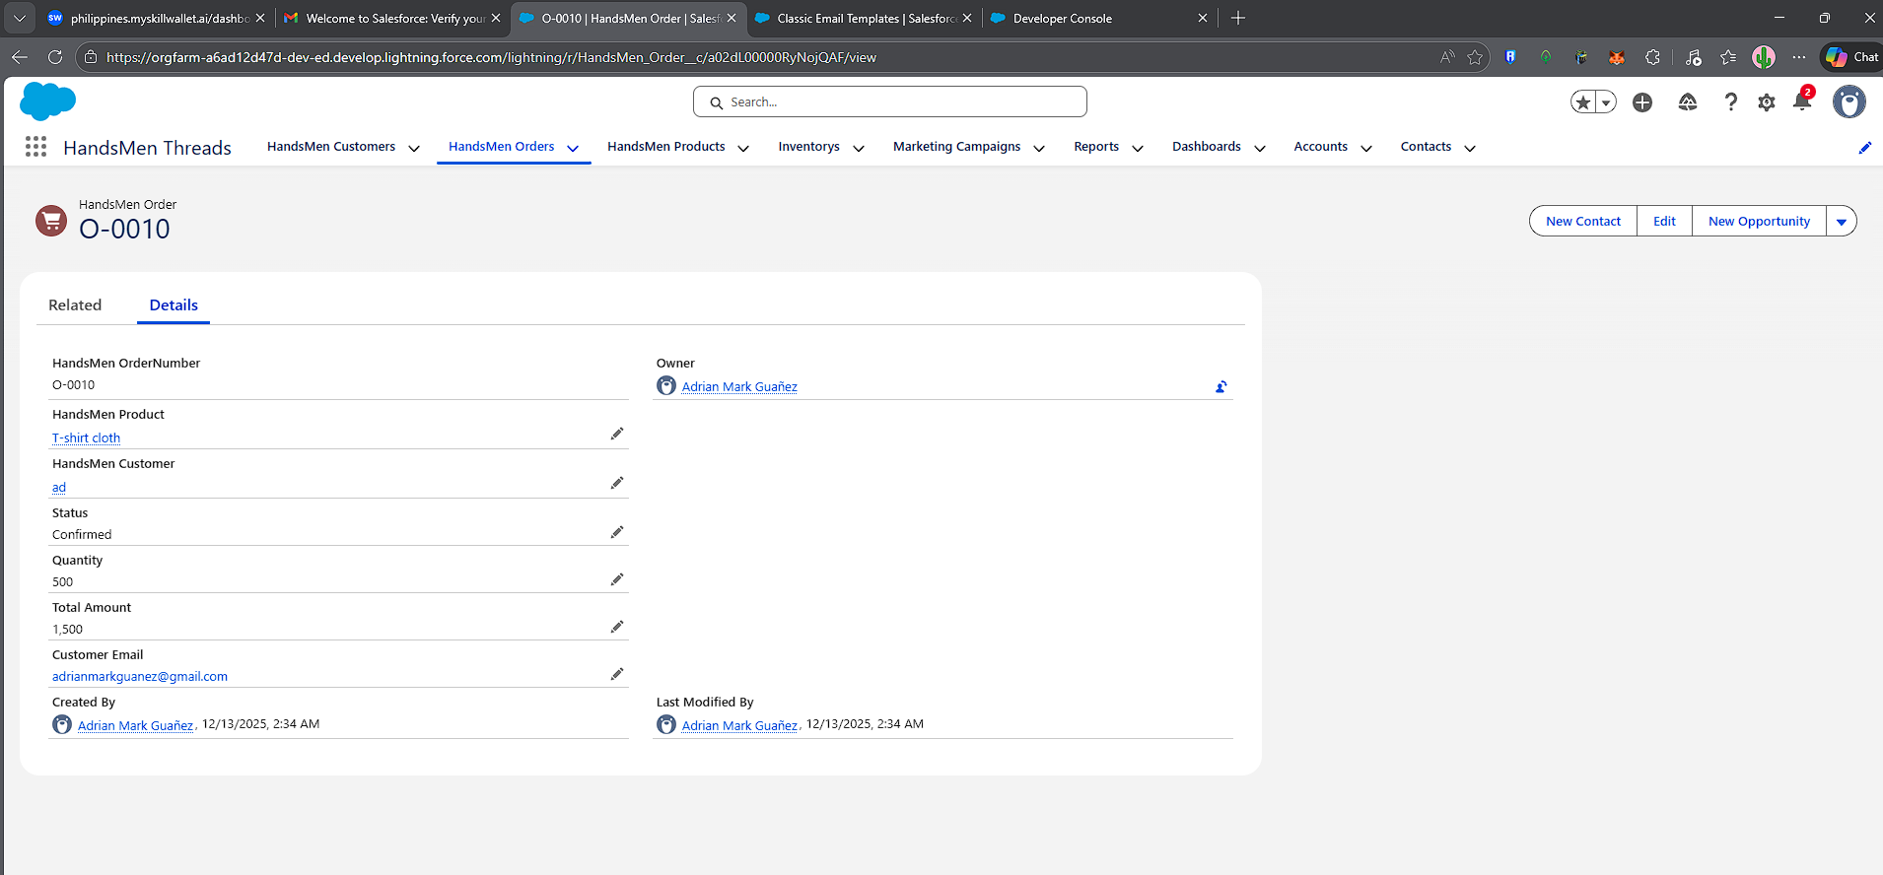
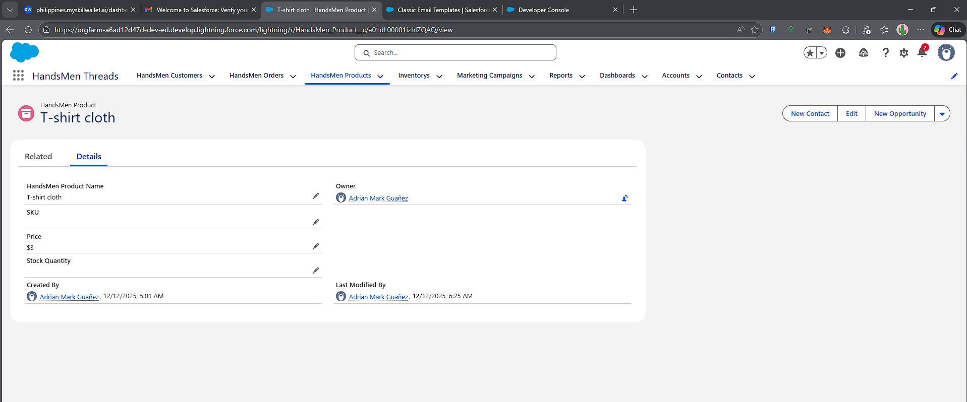
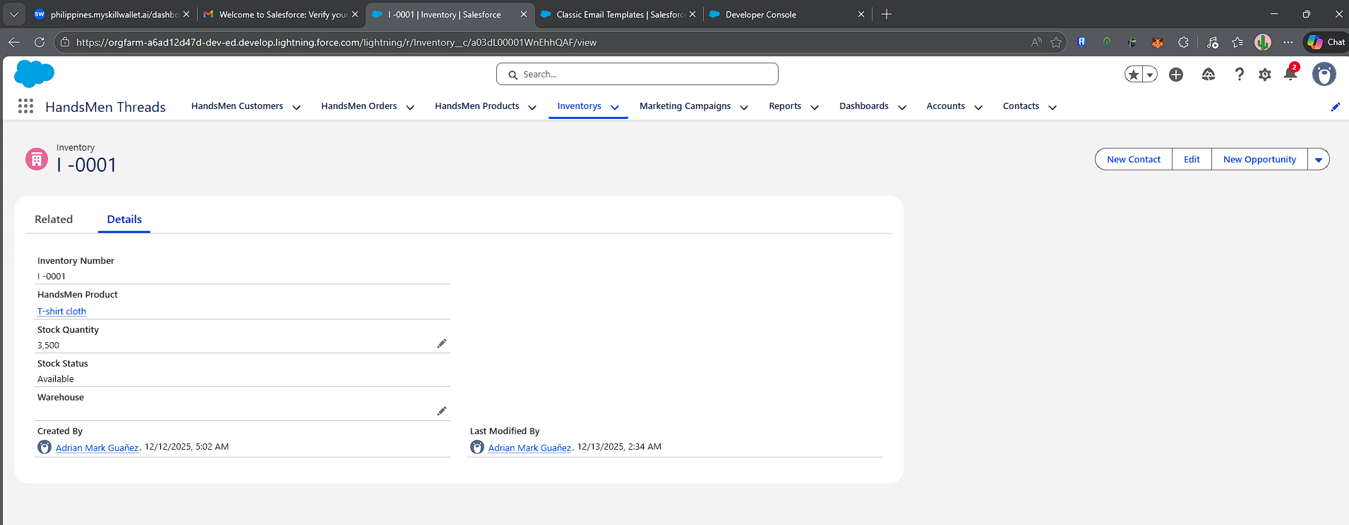
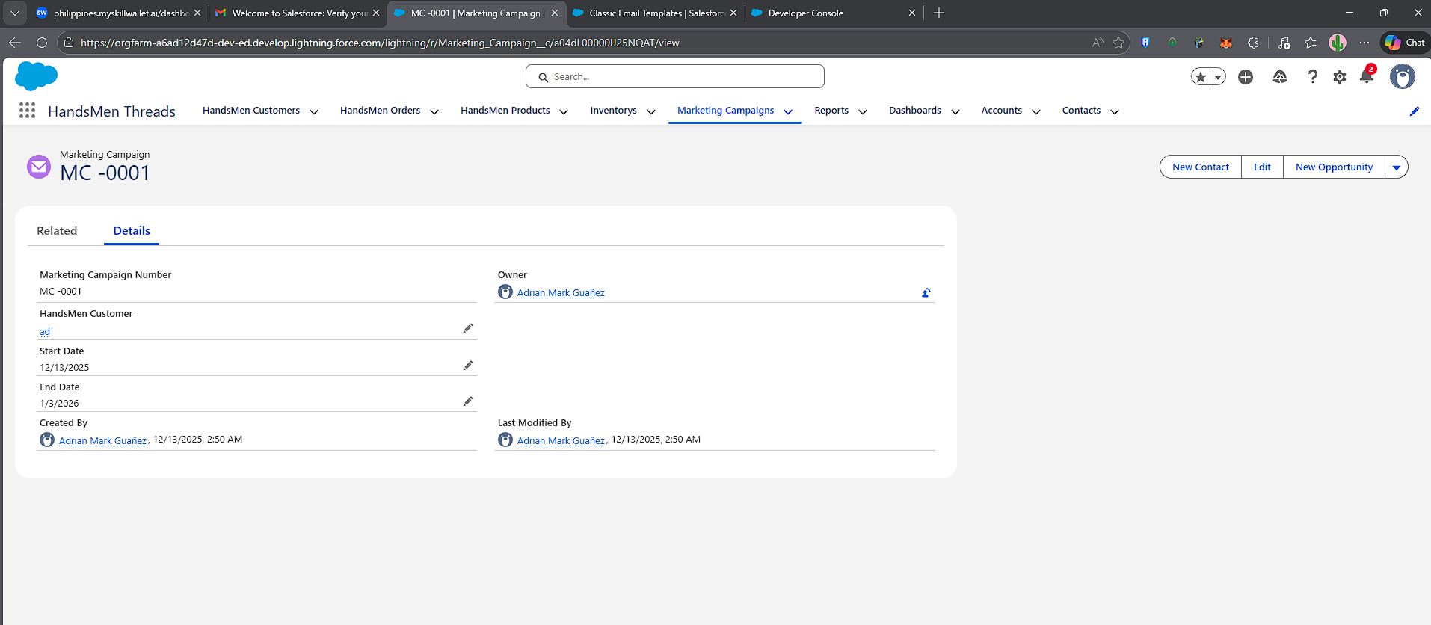

Conclusion
HandsMen Threads, a premium men's fashion brand, aims to leverage Salesforce to streamline operations, enhance customer experience, and optimize inventory management. This project focuses on implementing Salesforce CRM to manage customer orders, track inventory, automate marketing campaigns, and provide seamless customer service.
The project involves building a robust data model tailored to store all pertinent business data, ensuring a seamless flow of information across the organization.
A key aspect of this project is the maintenance of data integrity directly from the user interface (UI). This feature will safeguard the accuracy and consistency of the data, which is crucial for informed decision-making and reliable business operations.The project will integrate several new processes into the business workflow to improve customer service and operational efficiency

